

Holocaust Survivor Program hspoutreach@selfhelp.net 212-971-5475


Holocaust Survivor Program
When Holocaust survivors receive care that respects their experiences, they have the support needed to live dignified lives as they age.
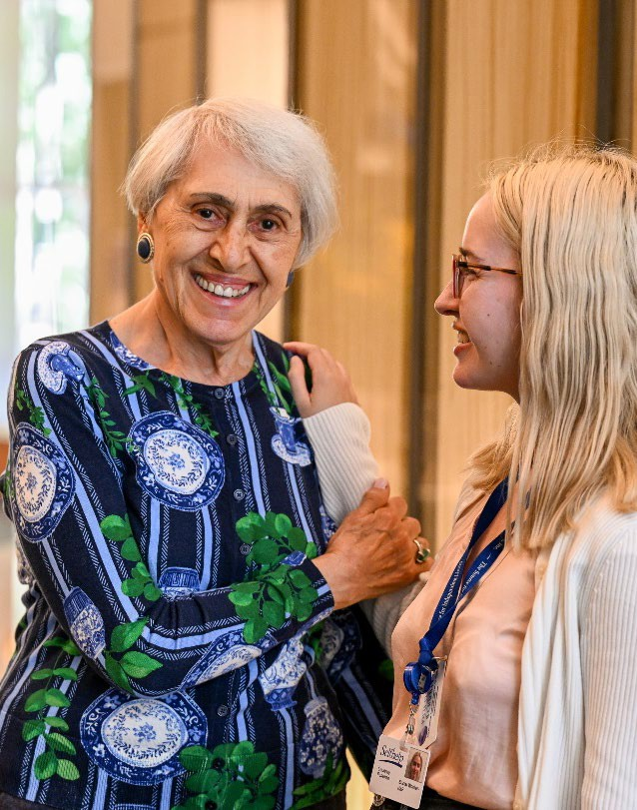
Aging Holocaust survivors face unique challenges receiving care, especially as their needs grow in complexity as they age. We are here to serve as the last surviving relative for every survivor.
- Operating the oldest and largest program providing comprehensive services to Holocaust survivors in North America more than 5,000 survivors
- Survivors are served by Person-Centered, Trauma-Informed (PCTI) trained professionals
- Offices in Manhattan, Queens, Brooklyn, the Bronx, and Nassau County
- Core services: enhanced case management, subsidized home care, emergency financial assistance, social events, guardianship and financial management, services for Russian-speakers, Witness Theater, and Holocaust education for the next generation

hspoutreach@selfhelp.net | 212-971-5475 | www.selfhelp.net

We believe that everyone deserves to age with compassionate, trusted, and innovative care that respects their life experiences. Our unique approach is rooted in our longstanding work with Holocaust survivors, giving us the experience and understanding to meet every challenge. Today, 25,000 people rely on us for affordable housing, home health care, and community-based services so they can age with dignity and independence. Social services to Holocaust survivors have been supported by a grant from the Claims Conference, UJA-Federation, JFNA, NYC Aging, and many others.
