
safetynet@selfhelp.net


Safety Net
When aging adults need a helping hand, they want to receive care where they feel valued and supported.

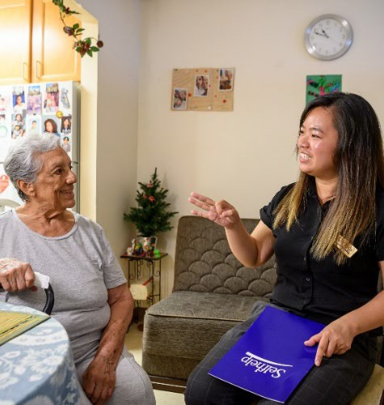
The Safety Net Case Management Program brings much-needed social services within reach.

Our caring team provides expert case management services for adults with disabilities and older adults living in select Brooklyn, Queens, and Manhattan zip codes.

- No income restrictions.
- Educate clients about social and human services eligibility.
- Referrals for housing, financial assistance, legal /immigration help, mental health services, citizenship and benefits assistance, home repairs, and more.

safetynet@selfhelp.net | (347) 289-8404 | www.selfhelp.net

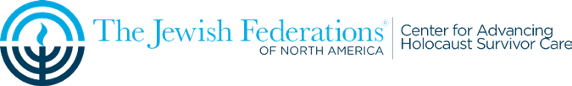


We believe that everyone deserves to age with compassionate, trusted, and innovative care that respects their life experiences. Our unique approach is rooted in our longstanding work with Holocaust survivors, giving us the experience and understanding to meet every challenge. Today, 25,000 people rely on us for affordable housing, home health care, and community-based services so they can age with dignity and independence. Safety Net is funded by UJA Federation of NY.

