

520 8th Avenue, 5th Floor New York, NY 10018 www.selfhelp.net


Selfhelp Community Services
Compassionate, trustworthy, and innovative
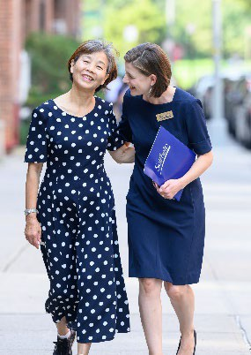
We believe that everyone deserves to age with compassionate, trusted, and innovative care that respects their life experiences. Our unique approach is rooted in our longstanding work with Holocaust survivors, giving us the experience and understanding to meet every challenge. Because every person deserves to age with dignity and independence.

Providing services for 25,00 aging adults:
- Community-Based Programs
- Home Care
- Affordable Housing Developer
- Specialized Services for Holocaust Survivors

Our Core Values:
- Welcome and Include All
- Think Big
- Connect with Compassion
- Build Trust, Always
- Balance Head and Heart

info@selfhelp.net | 212-947-8701 | www.selfhelp.net


