

NY Connects, Queens
45-35 Kissena Boulevard
Flushing, NY 11355
(718) 559-4400


NY Connects - Queens
When Queens residents need a helping hand, NY Connects is a phone call away
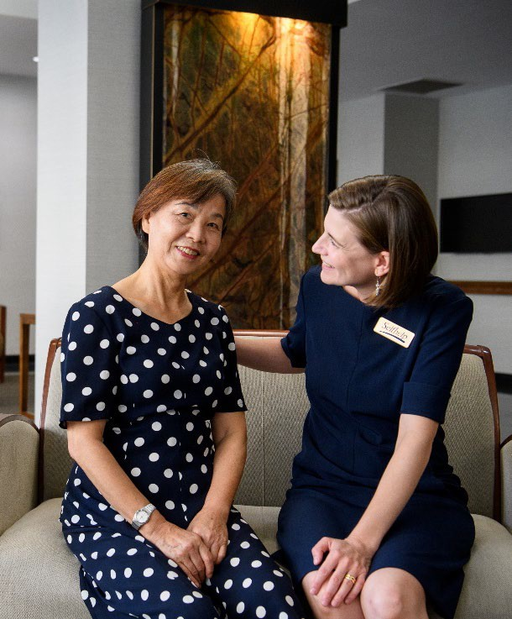
For people of all ages, any disability, and caregivers. NY Connects can work with anyone who needs information on long term services and supports — children or adults with disabilities, older adults, family members and caregivers, friends or neighbors, veterans, and helping professionals.

Community long term services and supports are designed to help people remain healthy and independent:
- Find care and support
- Remain independent
- Understand care options
- Find transportation
- Learn about supports in caregiving
- Find supported employment programs
- Get answers about Medicare
- Apply for Medicaid and other benefits

Call: (718) 559-4400 | Email: nyconnects@aging.nyc.gov

NY Connects is a NYS Office for the Aging Program


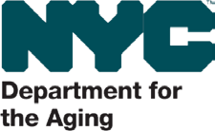
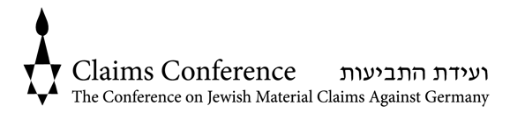
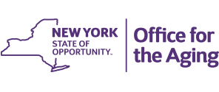
We believe that individuals deserve compassionate, trusted, and innovative care that respects their life experiences. Our unique approach is rooted in our longstanding work with Holocaust survivors, giving us the experience and understanding to meet every challenge. Because every person deserves to age with dignity and independence. We provide affordable housing, home health care, and community-based services to 25,000 people each year. NY Connects is a program of NYS Office of the Aging.

