


Selfhelp Community Services 520 8th Avenue, 5th Floor New York, NY 10018

Help When You Need It
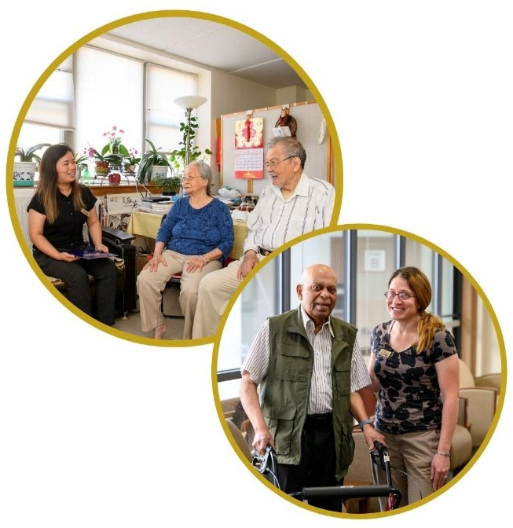
A collaborative approach to healthcare

It can be challenging navigating the healthcare system for adults 50+. For those with a history of missed appointments, multiple hospitalizations, non-adherence with treatment plans, it can be especially hard to stay well at home.

Selfhelp’s nurses and social workers are here to help. We build trust through home visits, geriatric wellness assessments, and care planning.

- Social work assessments and referrals for needed resources including entitlement and benefits, transportation, caregiver support, and more
- Licensed Practical Nurses (LPNs) schedule and accompany patients to appointments, and provide health education, and more
- Call for full eligibility details
- Not a good fit for those who are already enrolled in Health Home Care Management, living in supportive housing, receiving palliative or hospice care, or enrolled in managed long-term care

info@selfhelp.net | 212-947-8701 | www.selfhelp.net

