

www.selfhelp.net info@selfhelp.net 212-971-7600


Community-Based Programs
When aging adults need a helping hand, they want to receive care where they feel valued and supported
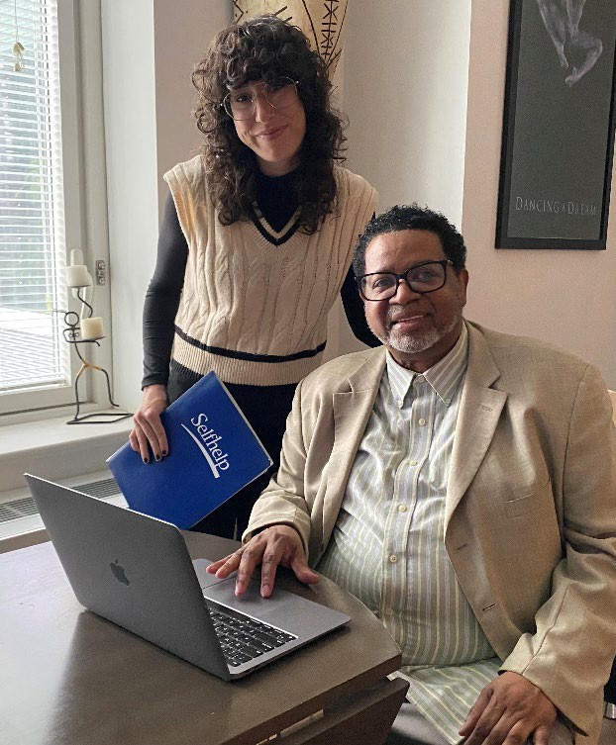
We all need community and connection to maintain our health and wellbeing. With dignity at the forefront, our Community-Based Programs bring much needed social services within reach.

- 5 Older Adult Centers
- 4 Naturally Occurring Retirement Centers
- 2 Case Management Programs
- SHARP: Selfhelp Alzheimer's Resource Program
- Community Guardianship
- Adult Protective Services
- NY Connects (Queens)
- Virtual Senior Center
- Selfhelp Active Services for Aging Model (SHASAM)

info@selfhelp.net | 212-947-8701 | www.selfhelp.net

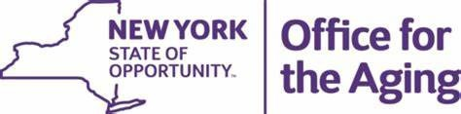
We believe that individuals deserve to age with dignity and independence. Every day we meet them where they are, providing care that responds to the needs of each person. Our unique approach is rooted in our longstanding work with Holocaust survivors, giving us the experience and understanding to meet every challenge. Because every person deserves compassionate, trusted, and innovative care that respects their life experiences. We provide affordable housing, home care, and community-based services to 25,000 individuals in the greater NYC metropolitan area.
