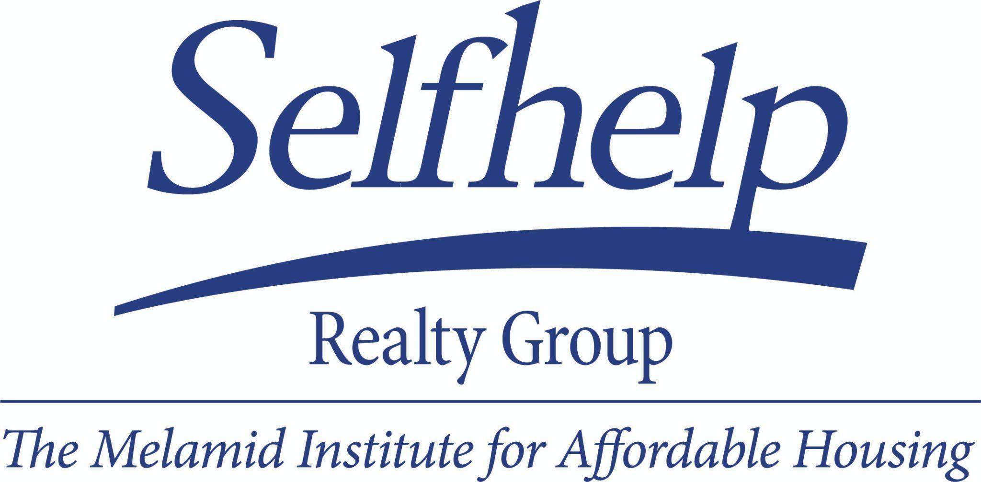



**FOR IMMEDIATE RELEASE**

**Contact:** Max Schulman, [max@anatgerstein.com](mailto:max@anatgerstein.com), 317-861-4167

**Selfhelp Realty Group Wins $1M in Buildings of Excellence Competition Award Funding**

*Award funding is granted for Selfhelp Kissena House project, an all-electric, energy-efficient residential building designed to provide 110 apartments for low-income older adults*

*Architectural firm Curtis + Ginsberg Architects receives award funding for design services*

[***Click here***](https://www.dropbox.com/scl/fi/v60p8dvtu9tsqmgb33gzy/Kissena-House-Revised-Rendering_300dpi.jpg?rlkey=522td4ndp1os9c51zd1txqioz&st=lgkoh9h6&dl=0) ***to view a rendering of the design***

**Flushing, Queens (June 17, 2025)** – Today, [Selfhelp Realty Group](https://selfhelp.net/realty/) announced it has won a $1 million Buildings of Excellence (BOE) Competition Award from the New York State Energy Research and Development Authority (NYSERDA) to support construction of its upcoming Kissena House, an all-electric, energy-efficient project featuring 110 apartments for low-income older adults.

The [BOE Competition](https://www.nyserda.ny.gov/All-Programs/Multifamily-Buildings-of-Excellence), which has been running since 2019, grants funding to “innovative and affordable” projects to lower emissions across New York’s buildings; the $1 million award to Selfhelp is the maximum award in the competition.

Kissena House, which is in the design phase, will be built on Selfhelp’s Flushing campus at 45th Avenue and Kissena Boulevard, and addresses two chronic challenges: a housing shortage and a climate crisis. The building will provide affordable apartments for older New Yorkers, [many of whom are facing housing instability](https://www.nytimes.com/2024/06/28/nyregion/nyc-homeless-older-people.html) and whose [poverty rates have surged over the past decade](https://nycfuture.org/research/the-emerging-financial-security-crisis-facing-older-adults-across-new-york). Additionally, the building will utilize renewable energy sources and incorporate architectural elements to meet the extremely energy-efficient standard of Passive House so it will require minimal energy and significantly reduce carbon emissions. Resident comfort is vastly improved in Passive House buildings.

“We are incredibly grateful and thank NYSERDA for receiving this substantial funding to advance a cutting-edge project that previews the potential of low- and no-emission affordable housing,” said **Lisa Trub, Executive Director of Selfhelp Realty Group**. “Affordable and efficient don’t have to be mutually exclusive, and this investment is a commitment to a project that accomplishes both. This NYSERDA award will help Selfhelp continue to build safe and beautiful permanently affordable housing for low-income New Yorkers*.*”

The building design is entirely electric and carbon-neutral-ready, with no use of fossil fuel combustion for daily operations. The building’s energy-efficient features will include:

* **Renewable Energy Sources**: All heating and cooling for the building will be generated via geothermal power and a solar array is planned for the roof.
* **Solar Shading**: Strategically implemented solar shade structures will be incorporated into unit windows to reduce heat uptake from the sun.
* **Passive Housing Envelope**: The envelope of the building, including windows, the roof, and walls, will be highly insulated to further reduce external heat uptake.

“The Buildings of Excellence Competition inspires projects that push the boundaries of clean, modern building design and construction to demonstrate pathways to zero-emission structures. Congratulations to the team behind the Kissena House project whose work exhibits how to meet the needs of the community while helping to further New York State’s efforts toward a more resilient future,” **said** **Doreen M. Harris, President and CEO, NYSERDA.**

The architectural team for the project, led by Curtis + Ginsberg Architects, will also receive award funding for their design services.

Selfhelp Kissena House will provide onsite social services to all residents through Selfhelp’s Active Services for Aging Model (SHASAM) which provides a comprehensive set of supports to help each person age with dignity. Stable housing does more than provide shelter. It stabilizes communities allowing older adults to age in place with independence and dignity, maintaining ties to neighbors, faith groups, and support networks. With the older, adult population in NYC expected to exceed 1.4M by 2030 and agency budgets stretched, Selfhelp brings unparalleled expertise in senior housing design, neighborhood engagement, and resident-focused services.

**About Selfhelp Realty Group |*The Melamid Institute for Affordable Housing*** increases aging New Yorkers’ access to housing by building and preserving affordable housing for older adults, with access to onsite social services through Selfhelp Active Services for Aging Model (SHASAM) to support residents living with dignity and independence. The Selfhelp Realty Group is a nonprofit developer with 19 buildings and 1,900 residents across New York City and Long Island. Selfhelp Realty Group is the housing arm of [Selfhelp Community Services](https://selfhelp.net/realty/), a nonprofit that supports aging with dignity and independence for 25,000 adults through home care, affordable housing, and community-based programs. [www.selfhelp.net](http://www.selfhelp.net)

###