*Address*

Tel:

www.selfhelp.net

***(Month)* Coffee House**

Selfhelp cordially invites you to attend our

Coffee House for lunch and entertainment

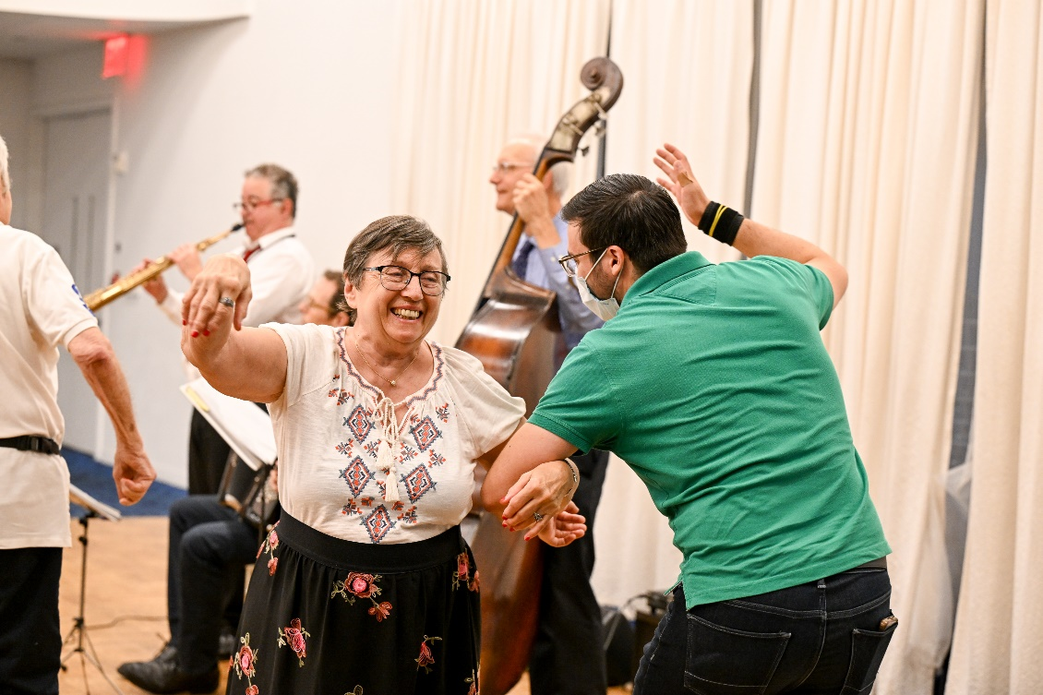

Location:

Date:

Time:

RSVP

**