**2024 Email Signature Guidelines**

An email signature is one of the easiest and most visible ways to communicate our identity to our community. Having a consistent email signature highlights our professionalism. Selfhelp’s standard email signature is written in Lato font size 10, with the disclaimer in size 8 font. Email signature should not be changed from the default style to reflect a personal preference.

**Copy and paste this signature into Outlook to easily transfer the images:**

Name

Title

Program Name (if applicable)

Selfhelp Community Services, Inc.

Office Address

New York, NY 10018

212-XXX-XXXX (office)

[email@selfhelp.net](mailto:email@selfhelp.net)

[www.selfhelp.net](http://www.selfhelp.net)



[Facebook logo](https://www.facebook.com/SelfhelpCommunityServices)  [Twitter logo](https://twitter.com/SelfhelpNY) [](https://www.instagram.com/selfhelpcommunityservices/) [](https://www.youtube.com/channel/UC-zzjIMeK9yuXUHdvjWY-GA)

NOTICE: The information contained in this e-mail message and any attachments is confidential and may be legally privileged. This message is intended only for the individuals(s) named herein or other contacts of Selfhelp Community Services Inc. specifically authorized to receive this communication. If you are not the intended recipient please notify the sender and delete the message immediately. Please do not read, store, copy or otherwise disseminate or distribute this e-mail or any part of it. Additionally, while this message and any attachments are believed to be free from any viruses or other defects that may affect the recipient’s systems, it is the responsibility of the recipient to scan for viruses before opening the e-mail. Selfhelp Community Services Inc. bears no responsibility for any loss or damage, arising in any way by receipt or use of the e-mail or any attachments.

Here’s how to update your signature:

1. Open a new email message. Select Signature > Signatures from the Message menu.

2. Under Select signature to edit, choose New, and in the New Signature dialog box, type a name for the signature.

3. Under Edit signature, compose your signature.

4. Under Choose default signature, add the email account you want the signature to be associated with and on new messages choose the name you gave the signature.

How to insert the logo and social media icons:

* While editing the signature you can add images with the add image icon. Next to the ‘add image’ icon is the hyperlink icon where you can highlight the image to add a hyperlink to each social media icon. When adding a hyperlink, paste the URL into the address field and click ok.

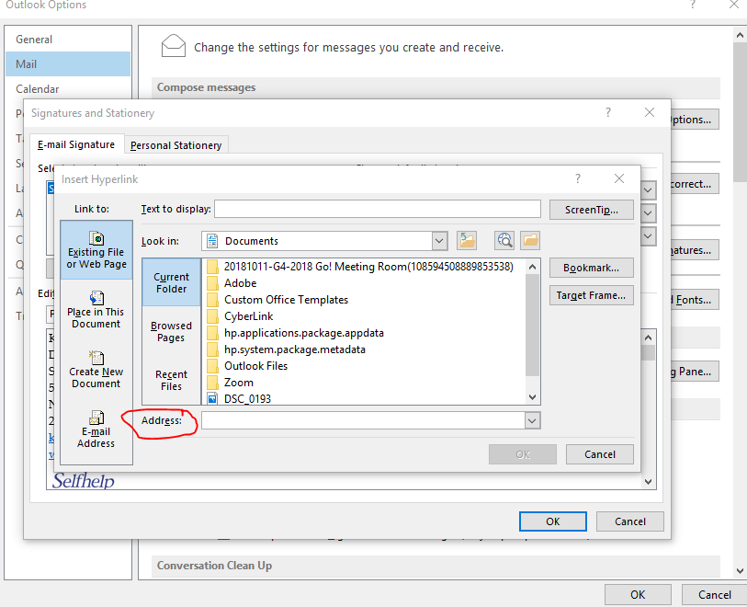

* Please confirm each logos is linked to the appropriate URL:

Selfhelp: <https://www.selfhelp.net/>

Facebook: <https://www.facebook.com/SelfhelpCommunityServices/>

Twitter: <https://twitter.com/selfhelpny>

Instagram: <https://www.instagram.com/selfhelpcommunityservices/>

YouTube: <https://www.youtube.com/channel/UC-zzjIMeK9yuXUHdvjWY-GA>

* The Selfhelp logo should be larger than the social media icons, but not overwhelm the email signature.

**Using Outlook Web App (**[**https://mail.selfhelp.net**](https://mail.selfhelp.net)**)**

1. Send an email to yourself with your updated signature. When you’ve opened Outlook Web App, copy this signature
2. On the top right of the web app screen, click the settings button next to your name and choose ‘options’



1. On the right side, click to open Settings
2. Under the email signature, paste your updated email signature.
3. Due to limitations in Outlook, it may not let you save the signature with images, including the Selfhelp logo and social media icons.
4. Click save at the bottom of the page.

**Example #1 - Administration**

Katie Foley, MSW

Director, Public Affairs

Selfhelp Community Services, Inc.

520 8th Avenue, 5th floor

New York, NY 10018

212-971-7605 (office)

[kfoley@selfhelp.net](mailto:kfoley@selfhelp.net)

[www.selfhelp.net](http://www.selfhelp.net)   


[Facebook logo](https://www.facebook.com/SelfhelpCommunityServices)  [Twitter logo](https://twitter.com/SelfhelpNY)  

NOTICE: The information contained in this e-mail message and any attachments is confidential and may be legally privileged. This message is intended only for the individuals(s) named herein or other contacts of Selfhelp Community Services Inc. specifically authorized to receive this communication. If you are not the intended recipient please notify the sender and delete the message immediately. Please do not read, store, copy or otherwise disseminate or distribute this e-mail or any part of it. Additionally, while this message and any attachments are believed to be free from any viruses or other defects that may affect the recipient’s systems, it is the responsibility of the recipient to scan for viruses before opening the e-mail. Selfhelp Community Services Inc. bears no responsibility for any loss or damage, arising in any way by receipt or use of the e-mail or any attachments.

**Example #2 – Senior Communities**

Jane Smith

Accountant

Community Guardian Program

Selfhelp Community Services, Inc.

520 8th Avenue, 5th floor

New York, NY 10018

212-971-XXXX (office)

[XXX@selfhelp.net](mailto:XXX@selfhelp.net)

[www.selfhelp.net](http://www.selfhelp.net)  


[Facebook logo](https://www.facebook.com/SelfhelpCommunityServices)  [Twitter logo](https://twitter.com/SelfhelpNY)  

NOTICE: The information contained in this e-mail message and any attachments is confidential and may be legally privileged. This message is intended only for the individuals(s) named herein or other contacts of Selfhelp Community Services Inc. specifically authorized to receive this communication. If you are not the intended recipient please notify the sender and delete the message immediately. Please do not read, store, copy or otherwise disseminate or distribute this e-mail or any part of it. Additionally, while this message and any attachments are believed to be free from any viruses or other defects that may affect the recipient’s systems, it is the responsibility of the recipient to scan for viruses before opening the e-mail. Selfhelp Community Services Inc. bears no responsibility for any loss or damage, arising in any way by receipt or use of the e-mail or any attachments.

**Example #3 – Home Care**

Jane Smith

Intake Coordinator

Licensed Home Care Services Agency

Selfhelp Community Services, Inc.

520 8th Avenue, 5th floor

New York, NY 10018

212-971-XXXX (office)

[XXX@selfhelp.net](mailto:XXX@selfhelp.net)

[www.selfhelp.net](http://www.selfhelp.net)   


[Facebook logo](https://www.facebook.com/SelfhelpCommunityServices)  [Twitter logo](https://twitter.com/SelfhelpNY)  

NOTICE: The information contained in this e-mail message and any attachments is confidential and may be legally privileged. This message is intended only for the individuals(s) named herein or other contacts of Selfhelp Community Services Inc. specifically authorized to receive this communication. If you are not the intended recipient please notify the sender and delete the message immediately. Please do not read, store, copy or otherwise disseminate or distribute this e-mail or any part of it. Additionally, while this message and any attachments are believed to be free from any viruses or other defects that may affect the recipient’s systems, it is the responsibility of the recipient to scan for viruses before opening the e-mail. Selfhelp Community Services Inc. bears no responsibility for any loss or damage, arising in any way by receipt or use of the e-mail or any attachments.

**Example #4 –** **Selfhelp Realty Group**

Jane Smith

Coordinator

Selfhelp Realty Group, Inc.

520 8th Avenue, 25th floor

New York, NY 10018

212-971-XXXX (office)

[jsmith@selfhelp.net](mailto:jsmith@selfhelp.net)

[www.selfhelp.net](http://www.selfhelp.net)   


[Facebook logo](https://www.facebook.com/SelfhelpCommunityServices)  [Twitter logo](https://twitter.com/SelfhelpNY)  

NOTICE: The information contained in this e-mail message and any attachments is confidential and may be legally privileged. This message is intended only for the individuals(s) named herein or other contacts of Selfhelp Community Services Inc. specifically authorized to receive this communication. If you are not the intended recipient please notify the sender and delete the message immediately. Please do not read, store, copy or otherwise disseminate or distribute this e-mail or any part of it. Additionally, while this message and any attachments are believed to be free from any viruses or other defects that may affect the recipient’s systems, it is the responsibility of the recipient to scan for viruses before opening the e-mail. Selfhelp Community Services Inc. bears no responsibility for any loss or damage, arising in any way by receipt or use of the e-mail or any attachments.

**Example #5 –** **SCS Foundation**

Jane Smith

Coordinator

Selfhelp Community Services Foundation, Inc.

520 8th Avenue, 25th floor

New York, NY 10018

212-971-XXXX (office)

[jsmith@selfhelp.net](mailto:jsmith@selfhelp.net)

[www.selfhelp.net](http://www.selfhelp.net)



[Facebook logo](https://www.facebook.com/SelfhelpCommunityServices)  [Twitter logo](https://twitter.com/SelfhelpNY)  

NOTICE: The information contained in this e-mail message and any attachments is confidential and may be legally privileged. This message is intended only for the individuals(s) named herein or other contacts of Selfhelp Community Services Inc. specifically authorized to receive this communication. If you are not the intended recipient please notify the sender and delete the message immediately. Please do not read, store, copy or otherwise disseminate or distribute this e-mail or any part of it. Additionally, while this message and any attachments are believed to be free from any viruses or other defects that may affect the recipient’s systems, it is the responsibility of the recipient to scan for viruses before opening the e-mail. Selfhelp Community Services Inc. bears no responsibility for any loss or damage, arising in any way by receipt or use of the e-mail or any attachments.